OOP PROJECT-CAB Management

UML:
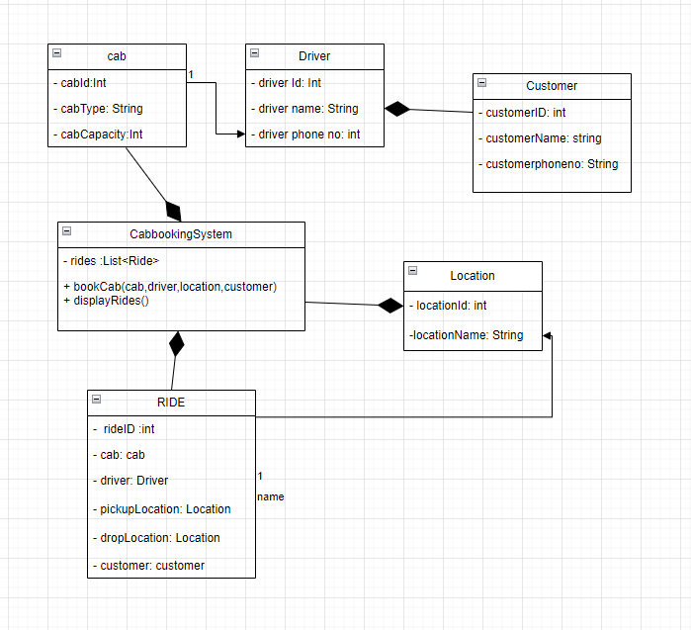

CODE:
import java.util.*;
// String Cab class
class Cab {
private int cabID;
private cabType;
private int capacity;

public Cab(int cabID, String cabType, int capacity) {
this.cabID = cabID;
this.cabType = cabType;
this.capacity = capacity;
}

public int getCabID() {
return cabID;
}

public String getCabType() {
return cabType;
}

public int getCapacity() {
return capacity;
}
}

// Driver class
class Driver {
private int driverID;
private String driverName;
private String driverPhoneNumber;

public Driver(int driverID, String driverName, String driverPhoneNumber) {
this.driverID = driverID;
this.driverName = driverName;
this.driverPhoneNumber = driverPhoneNumber;
}

public int getDriverID() {
return driverID;
}

public String getDriverName() {
return driverName;
}

public String getDriverPhoneNumber() {
return driverPhoneNumber;
}
}

// Location class
class Location {
private int locationID;
private String locationName;

public Location(int locationID, String locationName) {
this.locationID = locationID;
this.locationName = locationName;
}

public int getLocationID() {
return locationID;
}

public String getLocationName() {
return locationName;
}
}

// Customer class
class Customer {
private int customerID;
private String customerName;
private String customerPhoneNumber;

public Customer(int customerID, String customerName, String customerPhoneNumber) {
this.customerID = customerID;
this.customerName = customerName;
this.customerPhoneNumber = customerPhoneNumber;
}

public int getCustomerID() {
return customerID;
}

public String getCustomerName() {
return customerName;
}

public String getCustomerPhoneNumber() {
return customerPhoneNumber;
}
}

// Ride class
class Ride {
private int rideID;
private Cab cab;
private Driver driver;
private Location pickupLocation;
private Location dropLocation;
private Customer customer;

public Ride(int rideID, Cab cab, Driver driver, Location pickupLocation, Location dropLocation, Customer customer) {
this.rideID = rideID;
this.cab = cab;
this.driver = driver;
this.pickupLocation = pickupLocation;
this.dropLocation = dropLocation;
this.customer = customer;
}

public int getRideID() {
return rideID;
}

public Cab getCab() {
return cab;
}

public Driver getDriver() {
return driver;
}

public Location getPickupLocation() {
return pickupLocation;
}

public Location getDropLocation() {
return dropLocation;
}

public Customer getCustomer() {
return customer;
}
}

// CabBookingSystem class
class CabBookingSystem {
private List<Ride> rides;

public CabBookingSystem() {
this.rides = new ArrayList<>();
}

public void bookCab(Cab cab, Driver driver, Location pickupLocation, Location dropLocation, Customer customer) {
int rideID = rides.size() + 1;
Ride ride = new Ride(rideID, cab, driver, pickupLocation, dropLocation, customer);
rides.add(ride);
}

public void displayRides() {
System.out.println("Rides:");
for (Ride ride : rides) {
System.out.println("Ride ID: " + ride.getRideID());
System.out.println("Cab ID: " + ride.getCab().getCabID());
System.out.println("Cab Type: " + ride.getCab().getCabType());
System.out.println("Driver ID: " + ride.getDriver().getDriverID());
System.out.println("Driver Name: " + ride.getDriver().getDriverName());
System.out.println("Pickup Location: " + ride.getPickupLocation().getLocationName());
System.out.println("Drop Location: " + ride.getDropLocation().getLocationName());
System.out.println("Customer ID: " + ride.getCustomer().getCustomerID());
System.out.println("Customer Name: " + ride.getCustomer().getCustomerName());
System.out.println("Customer Phone Number: " + ride.getCustomer().getCustomerPhoneNumber());
System.out.println();
}
}
}

// Main class
public class Main2 {
public static void main(String[] args) {
Cab cab1 = new Cab(1, "Sedan", 4);
Driver driver1 = new Driver(1, "John", "1234567890");
Location pickupLocation1 = new Location(1, "ABC");
Location dropLocation1 = new Location(2, "XYZ");
Customer customer1 = new Customer(1, "Alice", "9876543210");
Cab cab2 = new Cab(2, "Hatchback", 4);
Driver driver2 = new Driver(2, "Jane", "0987654321");
Location pickupLocation2 = new Location(3, "PQR");
Location dropLocation2 = new Location(4, "LMN");
Customer customer2 = new Customer(2, "Bob", "1234567890");

CabBookingSystem cabBookingSystem = new CabBookingSystem();
cabBookingSystem.bookCab(cab1, driver1, pickupLocation1, dropLocation1, customer1);
cabBookingSystem.bookCab(cab2, driver2, pickupLocation2, dropLocation2, customer2);
cabBookingSystem.displayRides();
}
}

OUTPT:

